University of Missouri

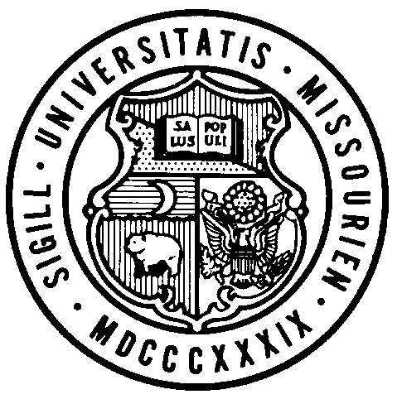
Board of Curators

Executive Committee Meeting

Friday, January 11, 2019
9:00 A.M.

Originating in 321 University Hall, Columbia, Missouri and at remote locations via conference telephone.

Public Session Dial-In Number: 888-606-4788
Conference Code: 822388#

AGENDA

PUBLIC SESSION – 9:00 A.M.

Call to Order – Executive Committee Chair Steelman

Roll Call of the Executive Committee

General Business

Action
- Approval, Board Executive Committee and Standing Committee Assignments
- Adjourn, Executive Committee Meeting

